**Tulsa brothers arrested for allegedly trafficking underage girlfriend**

by Megan Butler, KTUL Staff

Tuesday, November 5th 2019

AA

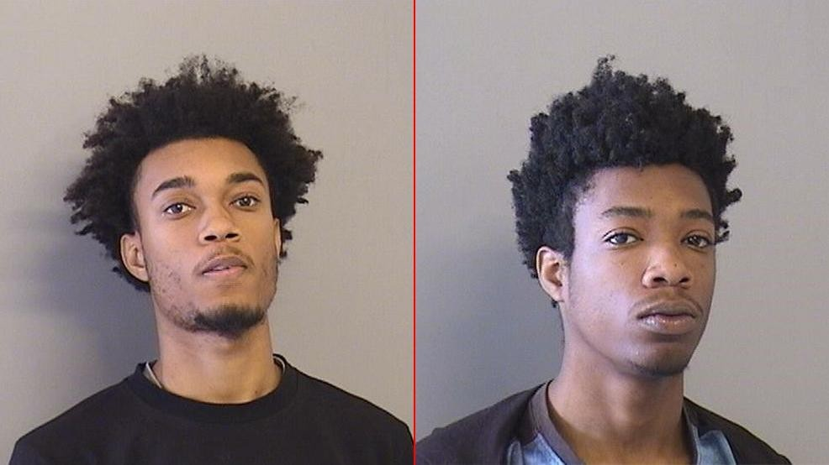

TULSA, Okla. (KTUL) — Tulsa police arrested two brothers in connection to a human trafficking investigation.

On Oct. 9, a young girl told officers she was 12 years old when she dated her ex-boyfriend, Kearis Snell, in April 2018.

She said she knocked on the front door, but Kearis was waiting for her outside. He told her she was going to "make some money."

When they went inside the house, he led her to a back bedroom, where she met his brother, Keandre Snell.

Keandre told the victim she would be giving him oral sex, and he told her he had money for her.

Before he could give her the money, Kearis said the money belonged to him. Keandre gave his brother about $50 to $80, according to the victim.

She broke up with Kearis in July 2018. She told police that he has constantly tried to contact her and has left multiple messages, saying she's "his" and that she owes him money.

The victim said Kearis had told her he'd rent a room at the Knights Inn in order to "make money." She refused.

She told police he also contacted her, saying she owes him money because he made a "job" for her and said he wanted more compensation.

The victim said Kearis "works" every girl he dates.

She told officers she was threatened by him multiple times and he has told her that "nobody is going to stop me from seeing you."

Police arrested Keandre on Oct. 31 and Kearis on Nov. 4 and booked them into the Tulsa County Jail. Both brothers are facing a child human trafficking charge, and Keandre is also facing a lewd molestation charge.

++++++++

**Tulsa brothers picked up on child human trafficking charges**

Two Tulsa brothers are in custody to face child human trafficking charges after the main defendant was picked up on Monday.

Kearis Travon Snell, 18, was booked into the Tulsa County jail about 11:35 a.m. on a charge of child human trafficking. His older brother, Keandre Leon Snell, 21, has been in the jail since Thursday on the same charge, plus an additional charge of lewd molestation.

Prosecutors allege Keandre paid Kearis for a sex act committed by a 12-year-old girl in the spring of 2018. The brothers were charged in Tulsa County District Court on Oct. 16. The victim told police she had been living with Kearis Snell and that they’d been involved in a relationship. One night he met her outside and told her she was going to “make some money,” according to a probable cause affidavit.

He led her to a back room where she performed a sex act on Keandre, and Kearis pocketed Keandre’s payment, the affidavit states.

Although the victim later ended the relationship with Kearis, she told police he has since incessantly attempted to contact her and threatened her, saying that he claimed her, she is “his,” and “nobody is going to stop me from seeing you.”

“The (victim) stated that Kearis ‘works’ every girl that he dates,” the affidavit states. “She also stated that Keandre ‘messes’ with younger girls.”

The brothers remained in jail Monday afternoon on $100,000 bonds. The fault never lies on the victims, Wilson said, but on their manipulators and those providing a demand for the crime.

The men involved in sex trafficking view the girls and women not as human beings, but as property, Wilson said. They are a means to an end for their business, and there’s a demand they’re trying to keep up with.

“You’d be shocked at who’s out there buying,” Wilson said. “We’re talking people out there from all walks of life, all socioeconomic statuses, all jobs.”

The Vice Unit bears a unique burden in investigating trafficking activity in Tulsa. Detectives receive many tips and pursue countless leads, but the crime itself is elusive and difficult to prove, Wilson said.

“This is a much more difficult crime to talk about than robbery or homicide or burglary, because people report that,” Wilson said. “There’s so much more going on that we don’t know about, and we know about a lot.”

Wilson said most females are victimized by someone they know, be it an acquaintance, friend, significant other, or even family member, and he urged residents to be in the know about their loved ones’ lives.

Be aware of what people are capable of, know the dangers of social media and dating apps, and make an effort to know who your loved one is hanging out with, Wilson said.

“Ignorance is bliss,” Wilson said. “But if you turn a blind eye to what is out there, you run the risk of somebody that you love being a victim.”

Lt. Brian Wilson, who oversees the Tulsa Police Department’s Vice Unit, said although it’s a common perception that most human trafficking victims come from out of state, it’s not the case in Tulsa.

“Disturbingly enough, it’s the girls and women here in Tulsa who are becoming victims of human trafficking,” he said.

Wilson said the most common victims are runaways or girls who have not been provided a healthy support system, and they are often victimized by people they think they can trust.

++++++++

2 Tulsa Brothers Arrested For Human Trafficking

TULSA, Oklahoma - Two brothers accused of trafficking a young girl and sexually assaulting her are behind bars Wednesday evening.

Tulsa Police said brothers Kearis and Keandre Snell worked together to traffic a young girl, and possibly more victims.

An affidavit says the victim, who was 12 at the time of the assault, was dating Kearis, now 18, in April 2018.

It says Kearis "informed her she was going to make some money," then it says 21-year-old Keandre sexually assaulted the girl. Kearis "took money from Keandre for the sexual act," court records state.

It says Kearis "works every girl he dates."

"It's very prevalent here," said Carrie Tabor, who works with Hope 918, an organization fighting trafficking and sexual exploitation.

She said victims are often brought into human trafficking at a young age.

"This girl is 12," Tabor said. "That's the average age of someone that becomes a victim of trafficking. It keeps happening younger and younger."

The victim said Kearis threatened her after ending the relationship in July 2018.

"There were so many other victims of these two brothers potentially," said Andrea Graver with the non-profit Defending Dignity.

She said most of the time - traffickers know their victims.

"What we see is they're being trafficked by someone they know," said Graver. "It's a boyfriend, a friend; it's a peer."

Both women said all victims of sex trafficking have an opportunity to recover and get help.

"We are here for you," Graver said.

Both men are in the Tulsa County Jail on charges of child human trafficking.

Their bonds are set at $100,000 each.